In order to determine which features could be added into the project, several websites will be observed to establish essential features provided. These observations will then be listed, to be discussed with group members to see if they will be additionally necessary to the group project. This can eventually help assist with meeting the client’s requirements or even making the website more aesthetically appealing and accessible as a whole.

The websites that will be observed will first be several textbook renting websites, then several online book stores to see how they have presented their businesses. Although book stores will fail to assist with providing renting/selling textbook options, analysing these websites assist with the presentation of the project. This is achieved by understanding how the user interface that consumers receive and how this can be adapted into the project.

|  |  |
| --- | --- |
| Textbook renting websites | Book stores |
| Zookal - https://www.zookal.com/ | Dymocks - https://www.dymocks.com.au/ |
| Chegg - http://www.chegg.com/textbooks/ | Book Depository - http://www.bookdepository.com/ |
| Jekkle - https://www.jekkle.com.au/ | QBD - https://www.qbd.com.au/ |

# Textbook renting/buying/selling websites;

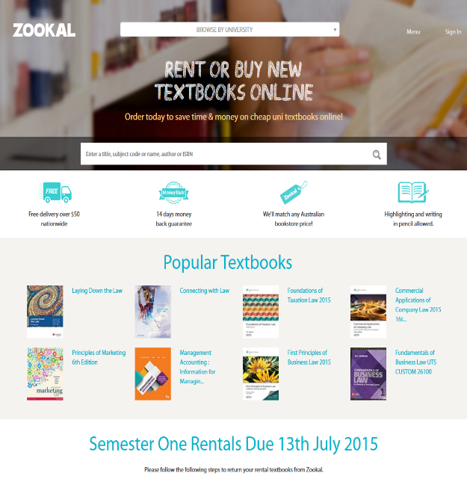**Zookal**

Zookal introduces a simple textbook transaction website designed for the Australian market for universities. Accessibility has been simplified by allowing a filtering option of which university the consumer is attending, then further extends to filtering which unit they are taking.

The main features of Zookal include;

* University/unit filtering system
* Guest and account login available
* Rentals have a set return date

Plays middle man and buys/sells textbooks

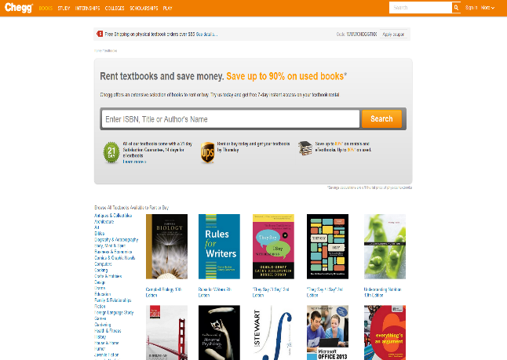**Chegg**

Much like Zookal, Chegg includes a search filtering system which accepts ISBN, titles, or authors name but introduces numerous categories for textbooks. However, Chegg is not entirely focused on the transaction of textbooks, presenting minimal tools available.

Features Chegg consist of are;

* Several purchase options are available once a textbook has been selected (e.g, ebook, rent, buying)
* Supplement and related textbooks are suggested on purchase page

**Jekkle**

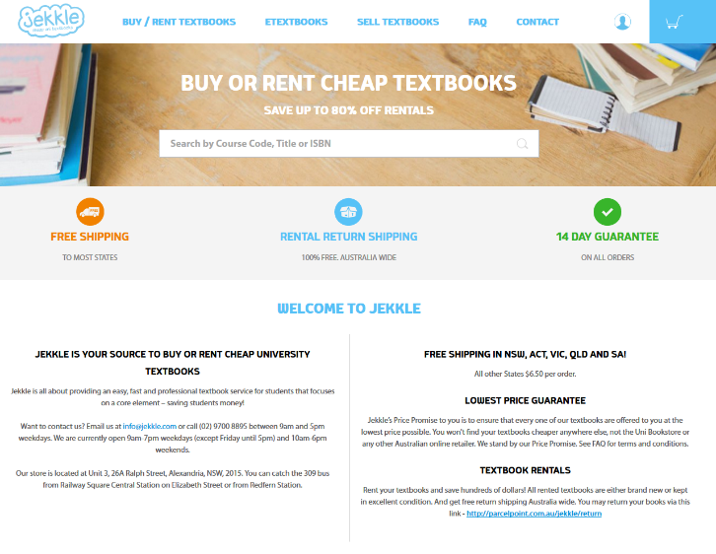Jekkal allows individuals to search up their course code in order to filter the textbooks associated with the course.

Features of Jekkal;

* Etextbooks and buy/renting textbooks are separately located on home page
* Conditions available of textbooks are presented below the title
* When selecting to add to cart, provided condition can be selected of item
* Related textbooks are shown

# Online Book stores

**Dymocks**

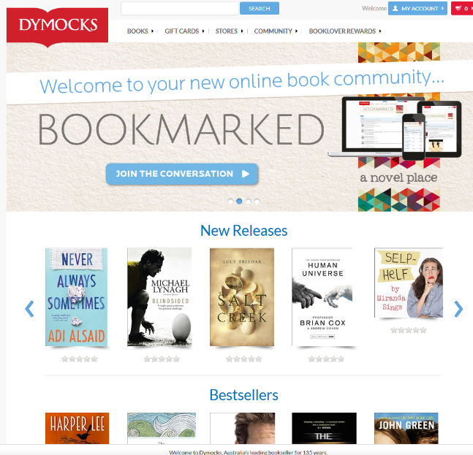Dymocks presents new releases, bestsellers, pre-order now, hot right now books on their home page. This allows an easy presentation and accessibility of popular books. In order to adapt this into the project, it is possible to allow users to filter to their university or unit code, then suggest them the textbook which is most popular for their search. This would have to be separate from the results, through possibility filter options or introduce a suggested list that is provided each search.

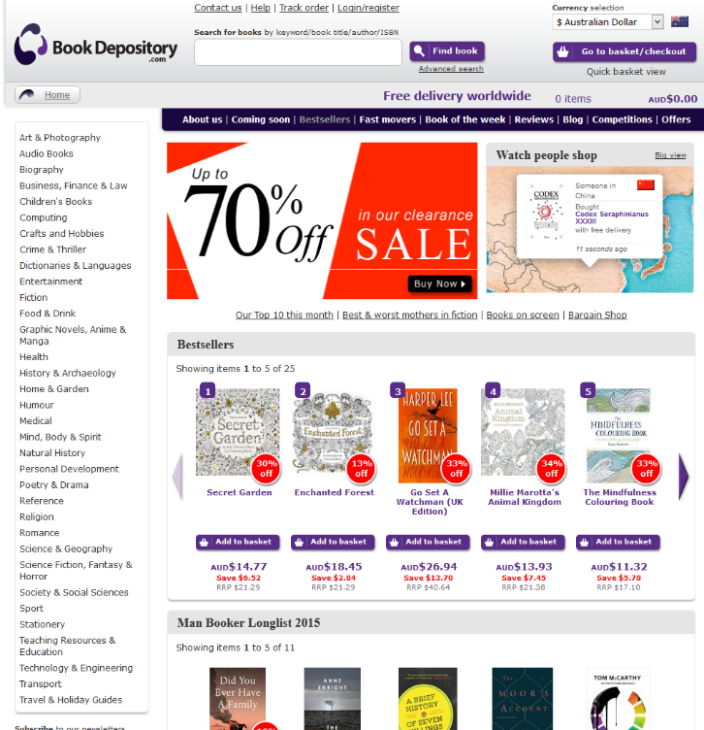**Book Depository**

The Book Depository follows the same concept as Dymocks, presenting several trending books on the homepage. However, Book Depository presents all the categories available in the store on the side for accessibility. Although this is not appealing, it is considered very easy to breakdown the categories of the books.

Books include ‘Other people who viewed this bought:’ and ‘Other book sin this category’ to allow the user to see what relatable books there are for the selected book. This introduces the incentive for users to buy more than one book. For easy access for previously viewed books, there is a personal wish list for each account and a shopping cart.

**QBD**

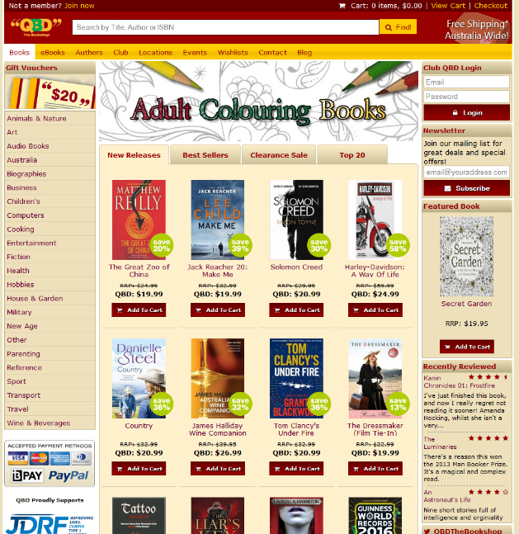QBD presents tabs which allow the user to see the trending books in each category, rather than only presenting a few, much like Dymocks and The Book Depository. QBD additionally presents their categories on the homepage but has minimialised the amount of categories they have compared to The Book Depository. QBD additionally includes a wishlist, and introduces additional features such as featured book, reviews and leaves a short ‘About us’ section in the home page.

This introduces many recommendations for users that have not selected a book they already want to buy, leaving room for suggestions to users. However, this is not necessary for the project as it should be clear which textbooks the user would want from the standard course undertaken and the intended units.

Features gathered:

Search feature – user can search for books through ISBN, Title, Authors

Warning system – user that act disorderly either not returning a book or not paying can get banned, depending on the offence there will be varying degrees of punishment.

Course Filtering – Books can be filtered by unit code to present results of suggested books for the unit

Dispute resolution – for transactions that do not meet the user’s expectation, support will be provided to assist with finding a solution that meets both parties’ demands.

Wish list system –allow users to bookmark books that they may wish to quickly refer back to for future transactions.

Suggested/ supplementary textbooks – Include additional textbook recommendations for a selected textbook which would be complementary.

Categories – for a project designed towards university textbooks, categories should be used to filter which textbooks are needed for a specific course.